EPA Wildfire Research and Tools Available
September 2020

- EPA conducts cutting-edge wildfire research to:
  - Improve methods to measure smoke emissions
  - Improve models that predict smoke transport, exposure and impacts on air quality
  - Expand understanding of health effects of smoke and evaluate solutions to reduce impacts
  - Investigate effects of burn area erosion on water quality
  - Identify and help protect at risk human populations and ecosystems
  - Evaluate and enhance communication strategies to find effective ways to reduce risks

- Current Research:
  - Smoke Sense Citizen Science Project is a mobile app where individuals can provide reports of smoke exposures, receive health risk communication messaging, and explore information about wildfires, smoke and air quality. The app has been downloaded over 34,000 times.
  - In the Wildfire-Advancing Science Partnerships for Indoor Reductions of Smoke Exposures (ASPIRE) Study, EPA is partnering with the Missoula City-County Health Department in Montana, University of Montana, and the Hoopa Valley Tribe in California. Scientists are analyzing indoor and outdoor fine particle (PM_{2.5}) concentrations to develop strategies for reducing indoor pollutant concentrations in public buildings during wildland fire smoke events. Researchers are also using mobile monitoring equipment to map smoke concentrations and observe how they vary when smoke funnels into mountain valleys and surrounding areas.
  - Researchers are evaluating the effectiveness of physical interventions, such as face masks and air filtration, to ameliorate the health effects of wildfire smoke exposure. Additional laboratory studies evaluate the effectiveness of portable air cleaners (including do-it-yourself, DYI, air cleaners) to reduce wildfire smoke exposure indoors.
  - EPA Office of Research and Development (ORD) researchers studied how low-cost PurpleAir sensor data compares to regulatory-grade monitors. This year the sensor data is included on the Fire and Smoke map at the AirNow site (operated by EPA’s Office of Air and Radiation) significantly increasing the spatial distribution of measurement data. The site received more than 4 million views since it launched in mid-August.
  - The Mobile Ambient Smoke Investigation Capability (MASIC) study focuses on understanding the chemistry and transport of smoke from wildfires by collecting air measurements with both reference and non-regulatory-grade technologies. Three comprehensive stationary sites have been established in Reno, NV; Boise, ID; and Missoula, MT. These measurements also contribute to Fire Influence on Regional to Global Environments Experiment - Air Quality (FIREX-AQ), a large interagency field study of fire emissions led by NASA and NOAA.

- Tools available:
  - Smoke Ready Toolbox for Wildfires – This website organizes wildfire smoke and health resources from federal, state and local agencies, making it easier to find information and educate people about the risks of smoke exposure and actions they can take to protect their health.
  - Wildfire Smoke Guide for Public Health Officials (2019)
  - Wildfire Smoke and Your Patients’ Health Web Course (2019)
Supporting details provided for background:

EPA’s Wildfire Response
Air Issues

- EPA has been partnering with state, local and tribal agencies to collect and display information about the path smoke is taking via monitoring and mapping, share best practices for communicating with the public about the health impacts of smoke, help officials on the ground make decisions about actions to lower people’s exposure to smoke, and ensure effective wildfire management, including promoting fire-adapted communities.
- EPA conducts cutting-edge wildfire research to improve smoke emissions measurement, modeling, toxicology, epidemiology, social science and health risk communication studies. EPA research allows better understanding of the impacts on human and ecosystem health and ways to reduce exposure.
- EPA’s commitment to providing the public with timely, accurate and consistent information about wildfire smoke means that we collaborate closely with federal, state, tribal and local agencies. The health effects of particle pollution from wildfire smoke exposure can range from relatively minor (e.g., eye and respiratory tract irritation) to more serious health effects (e.g., triggering and worsening of symptoms of asthma and chronic obstructive lung disease, heart failure, and premature death).

Collecting and Communicating Information about Air Quality
- Smoke Ready Toolbox for Wildfires – This website organizes wildfire smoke and health resources from federal, state and local agencies, making it easier to find information and educate people about the risks of smoke exposure and actions they can take to protect their health.
- AirNow – One-stop source for air quality data, especially during wildfire smoke episodes. Redesigned in early 2020, the site highlights air quality in the local area first, while still providing air quality information at state, national and world views. Site provides steps to protect health.
  - AirNow is a partnership of EPA, NOAA, NPS, NASA, CDC and tribal, state and local air quality agencies.
  - As indicated by EPA web stats from week of (8/24-30), people rely on AirNow during wildfires.
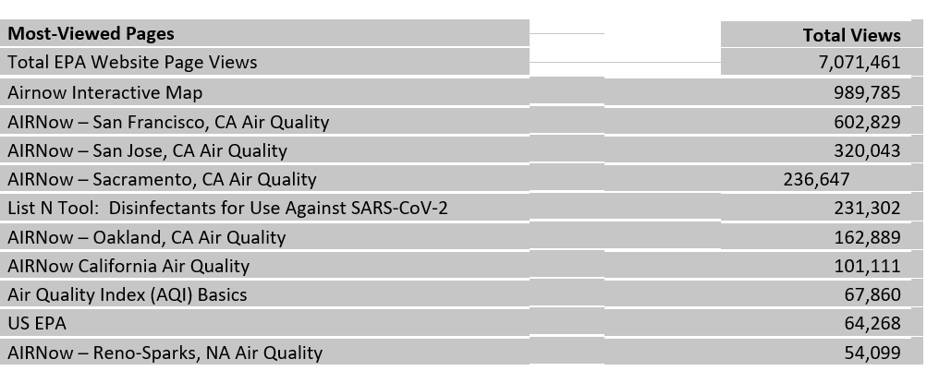

- AirNow Sensor Pilot – EPA and USFS are conducting a pilot project which adds add data from low-cost PurpleAir sensors to the Fire and Smoke map on AirNow.gov. While these sensors don’t meet the rigorous standards required for regulatory monitors, they help give a picture of local air quality in wildfire smoke conditions.
  - With the pilot, users have the option to turn on a “sensor layer” to add information from PurpleAir particle pollution sensors in their area. The new map layer allows people to see information from air quality monitors and low-cost sensors in one place, providing additional information on air quality that people can use to make decisions on outdoor activities to protect their health. This significantly increases the spatial distribution of measurement data and the site received more than 4 million views since it launched in mid-August.
  - The Fire and Smoke map, which has long been a feature of the AirNow site, already shows users information from permanent AirNow monitors and temporary monitors that the Forest Service has deployed near fires. It also lets users see fire locations, and smoke plume information from satellites.
  - Public use of low-cost sensors is increasing; however, sensor data is not comparable to data from the regulatory-grade monitors used on AirNow. The pilot project uses a scientific equation to “correct” the sensor data, so users can compare sensor information and monitor information side by side. ORD researchers provided technical details on this pilot project during a webinar for state and local air agencies and tribes on September 16.
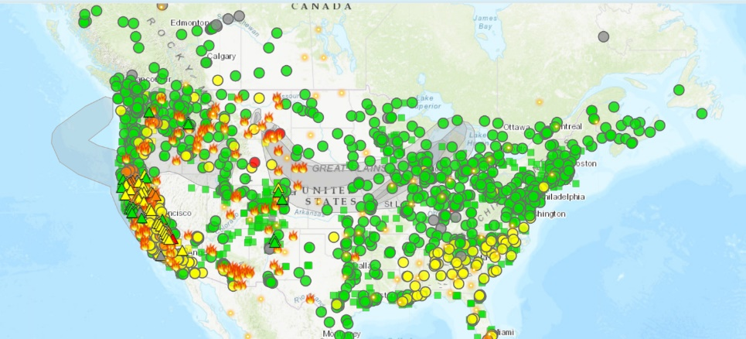
Screenshot of Fire and Smoke map with projected smoke plume (9/4/20 6:20AM.) Collaboration with EPA, USFS, and PurpleAir – a private company – to share information with the public using a mix of regulatory monitors and lower-cost sensors.
- Smoke Sense Citizen Science Project:
  - Aims to increase awareness about the health risks of breathing wildfire smoke and actions individuals can take to reduce the volume of smoke they breathe in.
  - The Smoke Sense mobile app is free to download and available on both iOS and Android phones. More than 34,000 individuals have downloaded the Smoke Sense app and each year thousands provide reports of smoke exposures, receive health risk communication messaging, and explore information about wildfires, smoke and air quality.
  - The Smoke Sense project also supports state and local strategies to protect and improve health through a two-way communication framework.

Helping Local Officials
- Wildfire Smoke Guide for Public Health Officials (2019)
  - Provides guidance for state, tribal and local public health and air agencies about protecting the public from exposure to wildfire smoke.
  - In addition to the information in the Guide, EPA’s post-publication updates help officials keep up with new information about the intersection of two emergencies – COVID-19 and wildfire smoke.
    - Multi-agency document developed by EPA, CDC, USFS and the California Air Resources Board and California Office of Environmental Health Hazard Assessment. ORD partnered with ECOS and ASTHO in 2016-2017 to "test drive" the guide and use their experience to provide feedback for the 2019 update.
- Wildfire Smoke and Your Patients’ Health Web Course (2019)
  - Intended for physicians, registered nurses, asthma educators and others involved in clinical or health education to help them learn about the health effects associated with wildfire smoke and actions for patients to take before and during a wildfire to reduce exposure.
- Smoke-Ready Communities – EPA and other federal agencies are supporting communities in efforts to reduce the public health burden of wildfire smoke events. To do this EPA is:
    - Identifying, gathering and making available existing resources to support local smoke event preparedness efforts.
    - Conducting applied research that 1) aids local communities in their smoke event preparedness efforts and 2) illuminates actionable strategies that EPA and partner agencies can take to improve tools and resources in this context.
    - Connecting with members of the National Tribal Air Association to help tribal communities build capacity to respond to fire events and raise awareness of Smoke-Ready Community resources and tools.
- Wildfire- Advancing Science Partnerships for Indoor Reductions of Smoke Exposures (ASPIRE) Study
  - Through the Wildfire-ASPIRE study, EPA is partnering in a study with the Missoula City-County Health Department in Montana, University of Montana, and the Hoopa Valley Tribe in California.
  - Scientists are analyzing data collected in Missoula and Hoopa to compare indoor and outdoor fine particle (PM_{2.5}) concentrations and to develop strategies for reducing indoor pollutant concentrations in public buildings during wildland fire smoke events.
  - In addition to stationary monitoring, researchers are using mobile monitoring equipment – an air sampling package the size of a brief case that can be mounted to any vehicle – to map outdoor smoke concentrations and observe how concentrations vary when smoke funnels into mountain valleys and surrounding areas.
  - These field studies will be complimented with laboratory studies to evaluate the effectiveness of portable air cleaners (including do-it-yourself, DYI, air cleaners) and air filtration systems to reduce wildfire smoke exposure indoors.
  - The results can help local officials, building owners and the public identify actions they can take to reduce health risks during smoke episodes.
- The Mobile Ambient Smoke Investigation Capability (MASIC) study
  - Launched in May 2019 to advance understanding of emissions from wildfires.
  - Researchers are collecting air measurements using both reference and non-regulatory-grade technologies to determine their performance capabilities during wildfire events. Three comprehensive stationary sites have been established in Reno, NV; Boise, ID; and Missoula, MT.
  - The MASIC study is also contributing to FIREX-AQ, a large interagency field study led by NASA and NOAA. Using satellites, aircraft, and ground monitoring, the study will help to answer how fuel and fire conditions may affect smoke components and chemistry, what conditions result in plume and transport of smoke over distances, and what impacts smoke has on air quality as it undergoes chemical transformation and aging. The results will be applied to remote sensing monitoring by satellites and models to improve predictions for smoke from wildfires and prescribed burns.
Ensuring Effective Wildfire Management
- EPA participates in the Wildland Fire Leadership Council (WFLC), an intergovernmental committee to support effective and efficient wildfire management, as well as the creation of fire-adapted communities and resilient landscapes to achieve long-range benefits for society.
  - In summer 2020, EPA worked with WFLC to craft a vision statement to ensure consistent messages around the use of prescribed fire.
  - At the request of the WFLC, EPA is leading an interagency effort with DOI and USFS to assess the impacts of different fire management regimes, including prescribed fire. The overall conclusions of this assessment will provide foundational information to support fire management decisions at the local to federal level.
- EPA researchers are:
  - Working to understand forest vulnerability to wildfire and how it might be changing in response to weather and ecosystem health
  - Developing models to improve spatial forecasting of wildfires on the basis of forest and ecosystem health
  - Working with EPA Regions to understand impacts of wildfire on water quality and ecosystem health by assessing the longer-term impacts following fires

- Air Resource Advisors (ARAs)
  - ARAs are technical experts who work with federal, state, tribal and local agencies during smoke events to assist with understanding and predicting smoke impacts on the public and fire personnel.
  - Led by USFS, EPA staff continue to be critical members of the ARA program as demand for it grows each year. This remains true during the pandemic, when USFS is deploying virtual ARAs.
  - Having ARAs on the incident command teams during wildfires provides the public with access to important on-the-ground information and advice on a daily basis to reduce exposures.
  - Their main task is to provide timely smoke impact and forecast information and messaging based on the best available science and current monitored conditions.

